WEEK 3
For 8-puzzle A* implementation, to calculate, f(n), consider two cases,
1. g(n): Depth of the node, h(n): Number of Misplaced tiles

import heapq
import copy

GOAL_STATE = [[1, 2, 3],
[8, 0, 4],
[7, 6, 5]]

def h_misplaced(state):
misplaced_count = 0
for i in range(3):
for j in range(3):
if state[i][j] != 0 and state[i][j] != GOAL_STATE[i][j]:
misplaced_count += 1
return misplaced_count

def get_neighbors(state):
neighbors = []
for i in range(3):
for j in range(3):
if state[i][j] == 0:
x, y = i, j
break

directions = [(-1, 0), (1, 0), (0, -1), (0, 1)]
for dx, dy in directions:
nx, ny = x + dx, y + dy
if 0 <= nx < 3 and 0 <= ny < 3:
new_state = copy.deepcopy(state)
new_state[x][y], new_state[nx][ny] = new_state[nx][ny], new_state[x][y]
neighbors.append(new_state)
return neighbors

def a_star_misplaced(initial_state):
open_list = []
heapq.heappush(open_list, (h_misplaced(initial_state), 0, initial_state, [initial_state]))
closed_set = set()

while open_list:
f, g, current, path = heapq.heappop(open_list)

if current == GOAL_STATE:
return path

current_tuple = tuple(tuple(row) for row in current)
if current_tuple in closed_set:
continue

closed_set.add(current_tuple)

for neighbor in get_neighbors(current):
neighbor_tuple = tuple(tuple(row) for row in neighbor)
if neighbor_tuple not in closed_set:
new_g = g + 1
new_h = h_misplaced(neighbor)
new_f = new_g + new_h
heapq.heappush(open_list, (new_f, new_g, neighbor, path + [neighbor]))

return None

initial_state = [[8, 1, 3],
[7, 2, 4],
[6, 0, 5]]

print("Misplaced Tiles Algorithm:")
path = a_star_misplaced(initial_state)

if path:
for step, state in enumerate(path):
print(f"Step {step}:")
for row in state:
print(row)
print()
print("Goal Found")
else:
print("Goal Not Found")

OUTPUT

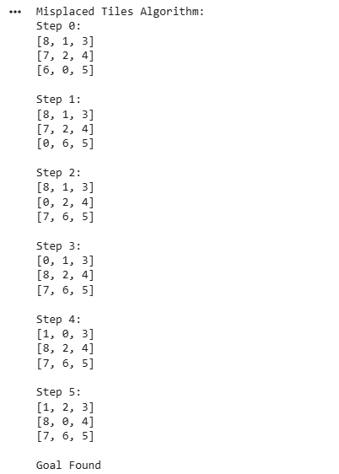

2. g(n): Depth of the node, h(n): Manhattan Distance
import heapq
import copy

GOAL_STATE = [[1, 2, 3],
[8, 0, 4],
[7, 6, 5]]

def h_manhattan(state):
total_distance = 0
for i in range(3):
for j in range(3):
value = state[i][j]
if value != 0:
for gi in range(3):
for gj in range(3):
if GOAL_STATE[gi][gj] == value:
total_distance += abs(i - gi) + abs(j - gj)
return total_distance

def get_neighbors(state):
neighbors = []
for i in range(3):
for j in range(3):
if state[i][j] == 0:
x, y = i, j
break

directions = [(-1, 0), (1, 0), (0, -1), (0, 1)]
for dx, dy in directions:
nx, ny = x + dx, y + dy
if 0 <= nx < 3 and 0 <= ny < 3:
new_state = copy.deepcopy(state)
new_state[x][y], new_state[nx][ny] = new_state[nx][ny], new_state[x][y]
neighbors.append(new_state)
return neighbors

def a_star_manhattan(initial_state):
open_list = []
heapq.heappush(open_list, (h_manhattan(initial_state), 0, initial_state, [initial_state]))
closed_set = set()

while open_list:
f, g, current, path = heapq.heappop(open_list)

if current == GOAL_STATE:
return path

current_tuple = tuple(tuple(row) for row in current)
if current_tuple in closed_set:
continue

closed_set.add(current_tuple)

for neighbor in get_neighbors(current):
neighbor_tuple = tuple(tuple(row) for row in neighbor)
if neighbor_tuple not in closed_set:
new_g = g + 1
new_h = h_manhattan(neighbor)
new_f = new_g + new_h
heapq.heappush(open_list, (new_f, new_g, neighbor, path + [neighbor]))

return None

initial_state = [[8, 0, 3],
[2, 1, 4],
[7, 6, 5]]

print("Manhattan Distance Algorithm:")
path = a_star_manhattan(initial_state)

if path:
for step, state in enumerate(path):
print(f"Step {step}:")
for row in state:
print(row)
print()
print("Goal Found")
else:
print("Goal Not Found")
OUTPUT
